Ben’s Lent Prayer Walk Challenge
Over lent Ben our vicar is inviting us all to pray for all the people who live the parish. For some of us that could include prayer walking down every street at least once over lent.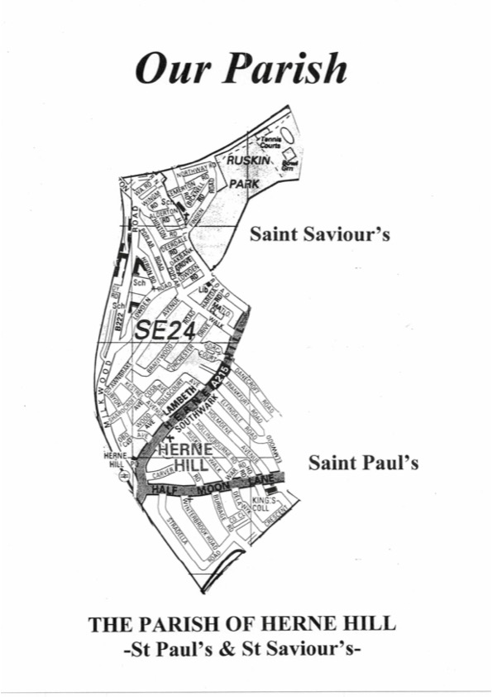
You could use the map on the other side if you wish and colour in the road once you’ve prayed for it. If you can’t do a prayer-walk please still pray at home if able.

Pray as you feel led, but feel free to use the blessings below as an anchor for prayers as well.

There are further prayers of blessing you could use on https://hernehillparish.org.uk/prayer/

Estates

I/we bless this estate in the name of Jesus to be a place of light and of loving community. I/we bless them with love, compassion, thoughtfulness and patience, as they live as close neighbours. May there be opportunities for the people living here to hear about the goodness of God and how much they are each loved by Him.

Homes

I/we bless this home, in the name of Jesus.
I/we bless it to be a place of safety both night and day.
I/we bless these walls and roof to stand strong and to be guarded by angels.
I/we bless the doors that they may open to provide joy and love to those inside and welcome others in to share that love and joy, through the gift of hospitality.
I/we bless the windows to allow in God's heavenly light, so it may then be carried out into dark places.

Broken-hearted

I/we bless the brokenhearted who feel crushed in their spirit, that their hearts would feel held
by God. I/we especially bless those who have lost a loved one recently and are feeling raw with grief right now. May they know the comfort of the Almighty and be held by their community.

Loneliness

I/we bless all who feel the pain of loneliness, to find a loving community. May they be blessed with friendships and love and become a blessing to others around them.
May we have eyes to see and ears to hear who these people are, so that we can become the answer to this prayer.

Homeless

I/we bless this homeless person in the name of Jesus, to soon feel the warmth and safety of a home. I/we bless them, that the peace and the joy of God may come upon him/her and wash them through every part of their being, physically, mentally, socially and spiritually.

Parks

I/we bless this open space in the name of Jesus to be a blessing to the community. May all ages enjoy and see God in His creation, through all the seasons. I/we bless this space to have an atmosphere of freedom that promotes health and healing to people’s body, mind and spirit.

Doctors' surgeries & Hospitals

I/we bless this medical building in the name of Jesus to be a place of healing and health. May the staff be protected as they serve the public. I/we bless all who enter here to experience the best care that they need and the love of Jehovah-Rapha, our healing God.

Residential/Nursing/Sheltered homes

I/we bless this home in the name of Jesus, that it may be a place of comfort and health. May the residents experience the best care and love and may the staff feel great joy in the work they do.
In this present situation may both residents and staff be protected and free from fear. May they know the presence of Jehovah-Shalom, our God of Peace.

Schools

I/we bless this school in the name of Jesus, that it may be a secure and safe place for teachers and pupils.
I/we bless the children's capacity to learn and play and develop relationships. I/we bless them to have an opportunity to hear about Jesus and His love for them. I/we bless them to grow like a mighty oak tree for the nations to marvel and see. I/we pray that those who lack hope will find shelter from the storms here.

Factory, workshop or offices

In the name of Jesus I/we bless those who work here, that they may know joy in their work, friendship in their workplace and that they may work well and effectively. I/we bless all the industry in this area, that it may continue to be a good means of income for many.
I/we bless this place, that safety and care may increase for all those that work here.

Town Square or Market

I/we bless this place in the name of Jesus and all who gather here. I/we bless those who work here, that God may prosper their businesses. I/we bless the conversations which take place, that they may be enriched by the wisdom of the Holy Spirit. I/we bless these streets, that they may be places of community and welcome.

Pharmacy

I/we bless the health of the people in this locality, that they may be strong and well. In Jesus' name I/we resist any sickness or disease which seeks to invade this town and to every person here we say: in Jesus’ name be strong, be healthy.
To any who are sick right now - I/we bless you in Jesus' name with a speedy recovery.

The local churches

I/we bless all the Christians in this place in the name of Jesus, for those who are part of the congregation here or who meet with other Christians elsewhere, that each one may be like a light shining out for all people to see.
I/we bless the Holy Spirit-given gifts of the Christians in this place, that He may flow like a river through each one of us.

Police Station or Court

I/we bless those who keep watch over the safety and integrity of this place in the name of Jesus. I/we also bless those who seek to ensure that there is justice for all.
In Jesus’ name I/we bless those who seek to restore those who fall and fail. (Why not bless your church to be part of this process.) We bless all of these people, that they may know integrity and act without favouritism.

Emergency Services

I/we bless all the different emergency workers in the name of Jesus. I/we bless them with peace and safety as they serve us so well. I/we bless them with physical, mental and emotional health as they help to keep our community safe.

Town Hall or Civic Offices

I/we bless, in the name of Jesus, all who work here and around this community to ensure that life is well ordered for all who live here. May the Holy Spirit be at work to promote beauty and joy as part of the heritage of this place.

Cultural Centre - Venue, Gallery, Theatre or Gardens

I/we bless this place, in the name of the God of beauty and creativity that we find expressed in Jesus, that it may be somewhere from which culture will spring up that brings glory to His Name.
I/we bless those who create things of beauty and craftsmanship that bring joy, delight and wonder. May the art and creativity of this place speak of His character and compassion.

Pubs

I/we bless this public house in the name of Jesus. May it be a place where healthy friendships are deepened, as people listen and share with one another. May the name of Jesus, who would often sit and proclaim truth with friends over a glass of wine, become regularly talked about within these walls. I/we bless the staff and the people enjoying the space with safety, peace and joy.

Shops

I/we bless this shop in the name of Jesus, that it will be able to serve its customers well and that the staff will experience joy in their employment. I/we bless this business to be successful for those employed here and the local community and economy.

Train station

I/we bless this train station in the name of Jesus to be a safe place of travel and as a meeting venue. I/we bless the atmosphere of this station to be warm and loving and full of the peace that passes all understanding. I/we bless everyone that works here with joy and safety in this place.

Bus stops

I/we bless this bus stop in Jesus’ name to be a place of safety and care. I/we bless this place to be filled with loving conversations and a space for quiet, peaceful reflection. I/we bless all the bus drivers with healthy postures as they sit for long periods and protection as they drive and deal with the public. I/we bless each bus that stops here to be covered with the protection of our heavenly Father.

Playgrounds

I/we bless this playground to be a place of joy and fun for families. I/we bless this area in the name of Jesus to be a safe place where families and friends can enjoy spending quality time with each other.

Pets and vets

I/we bless all the many different family pets in our area. Thank you God for the blessing and Joy that they bring to so many. I/we bless them to live in a safe and loving environment. I/we bless the local vets as they work to keep the animals healthy and happy.

Sports/clubs

I/we bless this place to be a blessing to our community. I/we bless it in the name of Jesus to be a place of fun and friendship that helps positively motivate people into a healthy lifestyle. I/we bless the conversations that happen in this place to include sharing the good news of Jesus.

Restaurants/cafes

I/we bless this establishment to be a place of warmth and welcome. May the people working here be treated well and enjoy serving this community. I/we bless the food and drink to be safe and healthy for those eating and drinking. May this place thrive economically and socially. I/we bless this place to be a blessing and may the love of God be demonstrated inside these walls.

Community spaces

I/we bless this space in the name of Jesus to be a blessing to this community. May it be a place of unity and growing friendships. May it be used to show love in practical ways. I/we bless this place with the Peace and Joy of the Lord.

Relationships

I/we bless all the different types of relationships and connections that people have in this area. I/we bless marriages, in the name of Jesus, to grow deeper in love. I /we bless family relationships between generations to be strengthened. I/we bless single people to find connections and friendships that bring them love and joy.

